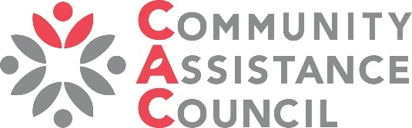

SKC Resources Fair
10 am to 1 pm, August 3, 2024, Optimist Bingo Hall, 11154 Blue Ridge Blvd, KCMO

Come share your information, activity and resources with south Kansas City residents 10 am to 1 pm, at the Optimist Bingo Hall, 11154 Blue Ridge Blvd, Kansas City, Mo. Nonprofits, businesses, government agencies, churches, homes/neighborhood associations and more are welcome to reserve a table, have a hands-on activity, provide a service onsite, share information, recruit prospective employees, or much more. We have a theme of safety and health, but all organizations are welcome. We ask that products and services not be sold onsite. Deadline to sign up for a table/s is July 29.

Each organization receives a 6-foot table and two chairs. Additional tables and chairs may be requested. Event is free for nonprofit organizations, $50 for for-profits. Set up opens at 9 am, we must be cleared out by 2 pm.

Please contact Staci Cooper, staci.cooper@cackc.org, 816-763-3277 with questions.

1. Your organization ___________________________________________________________

2. Organization contact name ____________________________________________________

3. Contact email _______________________________________________________________

4. Contact phone ______________________________________________________________

5. Name, cell phone, email for who most likely will be there that day (if different from above).

___________________________________________________________________________

6. Is your organization a:
__Nonprofit __Church __Homes/neighborhood association
__Government __School __Other non-taxed organization ____________________
__For-profit business* __Other ____________________________________________
For-profit businesses will be invoiced $50.

7. What type of activity, service or information will you likely provide? (If this changes significantly, please let us know to minimize any duplications.)

___________________________________________________________________________

___________________________________________________________________________

8. Does your service or activity require an electrical outlet? About 12 outlets will be available. __Yes

9. All organizations will have 1 table and 2 chairs. If you need additional, how many? __Tables __Chairs

10. How should your organizations be listed? If by name, please print below how you want it listed.

___________________________________________________________________

If by logo, please email a jpg or png of your logo to rachel.casey @cackc.org.

Send this completed form to staci.cooper@cackc.org, fax 816-763-5785,
complete online application at www.cackc.org/fair, or scan QR code to go to website.

